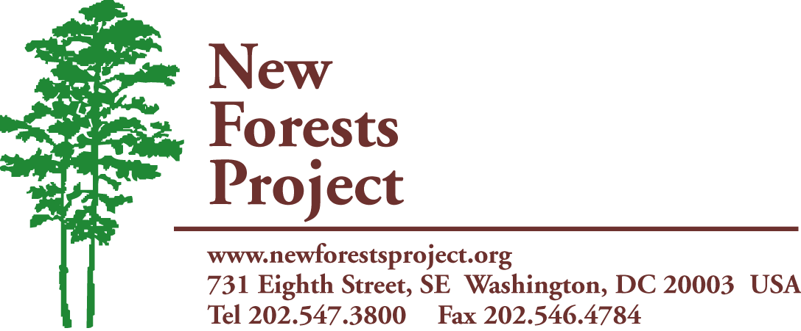
A Project of The International Center
www.newforestsproject.org

Small Grants

In order to apply for funds please complete the information specified below. Try to be as detailed as possible when describing your plans.

- Our small grants are usually in the range of US $500-$1,500.
- If your project is selected, we will only transfer the funds to bank accounts with the same name as the applying non-profit organization and that have a USA corresponding bank. We cannot transfer funds any other way.
- You must submit a copy of your organization’s official non-profit registration certificate together with your application.
- You can submit only one grant application to New Forests Project (NFP) per year.
- After the grant dispersal you will have to provide a quarterly report for the next year describing the trainings, outcomes, pictures, participants’ comments, and follow-up steps.

Please answer:
Our non-profit has a bank account with the same name as the non-profit and I have checked with the bank to make sure it can receive funds from a USA bank. I can provide necessary banking information (including U.S.A Correspondent Bank, address and SWIFT Code) if requested. Yes or No

I am including a copy of my organization’s registration certificate as a non-profit under country laws. Yes or No

We have the capacity to take pictures that we will be able to submit along with a report of the training. Yes or No

Small Grants Application

1. General Information
- Title of the project you are requesting funds for
- Country
- Amount of funds requested from the NFP in US dollars
- Approximate number of people affected
- Has your organization applied previously for financial support from NFP? If so, in what year?
- Has your organization received previous support (seeds, funds, or equipment) from NFP? If so, please specify of what kind and when.

2. Organization Background
- Name of the Organization
- Contact Information
- Name and title of contact person
- Organization address
- Phone/fax
- Email
- Type of Organization
Please include copy of your organization’s official non-profit registration certificate (for example, NGO or CBO registration certificate)
- Country, region, province/state
- Organization’s mission and year it was founded
- Types of projects (provide extra detail on your reforestation/agroforestry work)
- Area of work
- Number and responsibilities of staff
- Organization’s sources of funding
- Copy of organization’s official registration under a non-profit status (you can attach separately)

  - How are participants expected to benefit from this?

  - What are the planned follow-up activities? Describe, for example, if you are expecting participants to set up nurseries after training, and/or plant trees in their lands, and/or train other people (train- the-trainer). Include details of what you think is relevant to your efforts and what your organization’s role will be after the training.

  - Budget
Include a detailed budget specifying all expenses. Indicate the amount requested to the New Forest Project in US dollars. If applicable, specify amounts to be covered by the submitting organization or other organizations and how the contribution of NFP will be used.

